3.57: The range for a projectile that lands at the same height from which it was launched is 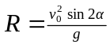, and the maximum height that it reaches is 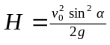. We must find R when 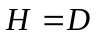 and 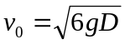. Solving the height equation for 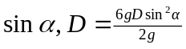, or 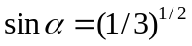. Then, 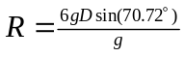, or 

